REHAU Specification Texts

RAUTITAN Plumbing and Gas systems

System Page

RAUTITAN platinum – hot and cold water 2

RAUTITAN red – hot water 4

RAUTITAN green – rainwater 6

RAUTITAN lilac – recycled water 8

RAUTITAN pink – under floor heating and cooling, radiator heating 10

RAUTITAN stabil – hot and cold water, and heating and cooling 12

RAUTITAN gas stabil – gas 14

Technical specification – REHAU RAUTITAN Plumbing System

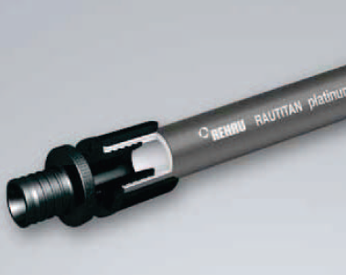
RAUTITAN platinum

- GENERAL
This section relates to REHAU RAUTITAN plumbing system for hot and cold water installation, from the network utility supply authority water main to designated points and appliances.

- System description
The REHAU RAUTITAN platinum plumbing system for hot and cold water applications of 16 to 63mm consists of:
- RAUTITAN platinum pipe
- PX fittings and sleeves
- MX fittings and sleeves

- Reference documentation
The documents referred to in this section are:
NCC / BCA Building Code of Australia
AS/NZS 3500 Plumbing and drainage set
AS/NZS 2492 Cross-linked polyethylene (PE-X) pipes for pressure applications
AS/NZS 2537 Mechanical jointing fittings for use with cross-linked polyethylene (PE-X) pipe for hot and cold water applications
AS/NZS 4020 Testing of products for use in contact with drinking water

Manufacturers documentation
Manufacturer’s and supplier’s documents relating to work in this section are:
REHAU RAUTITAN – Water, Gas & Heating Product book
REHAU Piping, Connection and System Guidelines – Technical information
RAUTITAN – Water Service – Technical Information

The above information is available from REHAU:
Web: www.rehau.com.au
Phone: 1300 768 033 (Australia only) or +61 2 8741 4500

- General system design and performance
Planning, installation and commissioning must comply with the following documents:
AS/NZS 3500.1 Plumbing and drainage – Part 1: Water Services
REHAU Piping, Connection and System Guidelines – Technical information
RAUTITAN – Water Service – Technical Information

Installers to be a member of the REHAU Authorised Installer Network RAIN, familiar with the materials and the techniques specified.

- MATERIALS

Pipe materials
Pipe materials shall be PE-Xa/PE construction, consisting of PE-Xa inner layer and a PE outer marking layer, certified to AS/NZS 2492 for water service applications.
Suitable for use in hot and cold water applications in buildings in accordance with AS/NZS 3500.

Pipe performance specification
Product | RAUTITAN platinum
Colour | Platinum (dark silver-grey)
Material | Flexible, high-pressure cross-linked polyethylene pipe PE-Xa (in accordance with DIN 16892/16893)
Pressure rating | PN20 (in accordance with AS/NZS 2492)
Design pressure | A Class.1-5/10bar (in accordance with ISO 15875)
Continuous operation | 70 °C at 1,000 kPa
Maximum operating temperature | 90 °C
short-term maximum temperature | 100 °C
Operational life time (at 70°C / 1,000 kPa) | 50 years
Available sizes in mm | 16 x 2.2mm 40 x 5.5mm  20 x 2.8mm 50 x 6.9mm  25 x 3.5mm 63 x 8.6mm  32 x 4.4mm
Australia and New Zealand approvals and certifications | AS/NZS 2492:2007  AS/NZS 4020  BRANZ appraisal no. 434  Watermark licence number LN01413

Pipe sizes 16mm and 20mm also available as pre-insulated pipe R=0.3 with outer PE insulation foam, with tear-resistant and moisture-blocking outer layer, for protection against heat loss in hot water pipes, condensation and heating of cold water pipes and as a sound insulation when installed in concealed location.

Connection – compression fittings and sleeves
Connections shall be axial compression sleeve mechanism, featuring the following benefits:
- Permanently sealing compression sleeve jointing technique
- Self-sealing pipe material – connection without the use of an O-ring
- Increased hydraulic properties based on expansion technology
- Approved for flush-mounted installation
- Robust jointing technique highly suitable for construction sites.
- Simple visual inspection
- Joint can be pressurised immediately after installation.
- Requires no calibration or deburring
- Same jointing technique and tools for water services, gas and heating installation

Fittings and sleeves shall be REHAU RAUTITAN PX or MX, Watermark approved and certified to AS/NZS 2537.

RAUTITAN PX Polymer fittings made of PPSU (colour: black) with tool tabs for precise attachment of the assembly tool RAUTOOL shall be used for threadless connections from 16-40mm.

RAUTITAN PX multi directional polymer sleeves made of PVDF (colour: black) with laser engraved production date shall be used for all connections from 16-40mm.

RAUTITAN MX DZR Brass fittings made of special dezincification-resistant brass, manufactured in accordance with AS2345, DIN EN 12164, DIN EN 12165 and DIN EN 12168 grade A (equivalent to highest requirement category), shall be used for all 16-63mm threaded connections and 50-63mm threadless connections.

RAUTITAN MX sleeves made of thermally annealed brass, manufactured in accordance with DIN EN 12164, DIN EN 12165 and DIN EN 12168, shall be used for connections 50-63mm.

- Manufacturer Warranty
Warranty period: 25 years
From: Date of completion of system testing.
For Terms and Conditions see REHAU RAUTITAN Warranty Certificate in the manufacturer’s standard form.

Technical specification – REHAU RAUTITAN Plumbing System

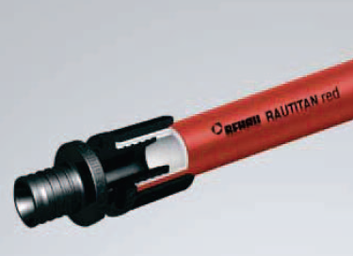
RAUTITAN red

- GENERAL
This section relates to REHAU RAUTITAN plumbing system for hot installation, from the network utility supply authority water main to designated points and appliances.

- System description
The REHAU RAUTITAN red plumbing system for hot water applications of 16 to 25mm consists of:
- RAUTITAN red pipe
- PX fittings and sleeves
- threaded MX fittings

- Reference documentation
The documents referred to in this section are:
NCC / BCA Building Code of Australia
AS/NZS 3500 Plumbing and drainage set
AS/NZS 2492 Cross-linked polyethylene (PE-X) pipes for pressure applications
AS/NZS 2537 Mechanical jointing fittings for use with cross-linked polyethylene (PE-X) pipe for hot and cold water applications
AS/NZS 4020 Testing of products for use in contact with drinking water

Manufacturers documentation
Manufacturer’s and supplier’s documents relating to work in this section are:
REHAU RAUTITAN – Water, Gas & Heating Product book
REHAU Piping, Connection and System Guidelines – Technical information
RAUTITAN – Water Service – Technical Information

The above information is available from REHAU:
Web: www.rehau.com.au
Phone: 1300 768 033 (Australia only) or +61 2 8741 4500

- General system design and performance
Planning, installation and commissioning must comply with the following documents:
AS/NZS 3500.1 Plumbing and drainage – Part 1: Water Services
REHAU Piping, Connection and System Guidelines – Technical information
RAUTITAN – Water Service – Technical Information

Installers to be a member of the REHAU Authorised Installer Network RAIN, familiar with the materials and the techniques specified.

- MATERIALS

Pipe materials
Pipe materials shall be PE-Xa/PE construction, consisting of PE-Xa inner layer and a PE outer marking layer, certified to AS/NZS 2492 for water service applications.
Suitable for use in hot water applications in buildings in accordance with AS/NZS 3500.

Pipe performance specification
Product | RAUTITAN red
Colour | Red
Material | Flexible, high-pressure cross-linked polyethylene pipe PE-Xa (in accordance with DIN 16892/16893)
Pressure rating | PN20 (in accordance with AS/NZS 2492)
Design pressure | A Class.1-5/10bar (in accordance with ISO 15875)
Continuous operation | 70 °C at 1,000 kPa
Maximum operating temperature | 90 °C
short-term maximum temperature | 100 °C
Operational life time (at 70°C / 1,000 kPa) | 50 years
Available sizes in mm | 16 x 2.2mm  20 x 2.8mm  25 x 3.5mm
Australia and New Zealand approvals and certifications | AS/NZS 2492:2007  AS/NZS 4020  BRANZ appraisal no. 434  Watermark licence number LN01413

Connection – compression fittings and sleeves
Connections shall be axial compression sleeve mechanism, featuring the following benefits:
- Permanently sealing compression sleeve jointing technique
- Self-sealing pipe material – connection without the use of an O-ring
- Increased hydraulic properties based on expansion technology
- Approved for flush-mounted installation
- Robust jointing technique highly suitable for construction sites.
- Simple visual inspection
- Joint can be pressurised immediately after installation.
- Requires no calibration or deburring
- Same jointing technique and tools for water services, gas and heating installation

Fittings and sleeves shall be REHAU RAUTITAN PX, Watermark approved and certified to AS/NZS 2537.

RAUTITAN PX Polymer fittings made of PPSU (colour: black) with tool tabs for precise attachment of the assembly tool RAUTOOL shall be used for threadless connections from 16-25mm.

RAUTITAN PX multi directional polymer sleeves made of PVDF (colour: black) with laser engraved production date shall be used for all connections from 16-25mm.

RAUTITAN MX DZR Brass fittings made of special dezincification-resistant brass, manufactured in accordance with AS2345, DIN EN 12164, DIN EN 12165 and DIN EN 12168 grade A (equivalent to highest requirement category), shall be used for all 16-25mm threaded connections.

- Manufacturer Warranty
Warranty period: 25 years
From: Date of completion of system testing.
For Terms and Conditions see REHAU RAUTITAN Warranty Certificate in the manufacturer’s standard form.

Technical specification – REHAU RAUTITAN Plumbing System

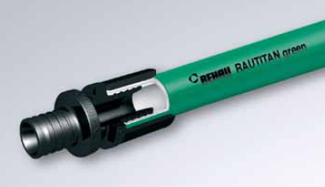
RAUTITAN green

- GENERAL
This section relates to REHAU RAUTITAN rainwater supply system, from the rainwater storage tank to designated points and appliances.

- System description
The REHAU RAUTITAN green plumbing system for rainwater applications of 16 to 63mm consists of:
- RAUTITAN green pipe
- PX fittings and sleeves
- threaded MX fittings

- Reference documentation
The documents referred to in this section are:
NCC / BCA Building Code of Australia
AS/NZS 3500 Plumbing and drainage set
AS/NZS 2492 Cross-linked polyethylene (PE-X) pipes for pressure applications
AS/NZS 2537 Mechanical jointing fittings for use with cross-linked polyethylene (PE-X) pipe for hot and cold water applications

Manufacturers documentation
Manufacturer’s and supplier’s documents relating to work in this section are:
REHAU RAUTITAN – Water, Gas & Heating Product book
REHAU Piping, Connection and System Guidelines – Technical information
RAUTITAN – Water Service – Technical Information

The above information is available from REHAU:
Web: www.rehau.com.au
Phone: 1300 768 033 (Australia only) or +61 2 8741 4500

- General system design and performance
Planning, installation and commissioning must comply with the following documents:
AS/NZS 3500.1 Plumbing and drainage – Part 1: Water Services
REHAU Piping, Connection and System Guidelines – Technical information
RAUTITAN – Water Service – Technical Information

Installers to be a member of the REHAU Authorised Installer Network RAIN, familiar with the materials and the techniques specified.

- Materials

Pipe materials
Pipe materials shall be PE-Xa/PE construction, consisting of PE-Xa inner layer, a black PE middle layer and a PE outer marking layer, certified to AS/NZS 2492 for water service applications.
Suitable for use in rainwater applications in buildings in accordance with AS/NZS 3500.

Pipe performance specification

Product | RAUTITAN green
Colour | green
Marking (each meter of pipe length) | “Rainwater”
Material | Flexible, high-pressure cross-linked polyethylene pipe PE-Xa (in accordance with DIN 16892/16893)
Pressure rating | PN20 (in accordance with AS/NZS 2492)
Design pressure | A Class.1-5/8bar (in accordance with ISO 15875)
Continuous operation | 70 °C at 1,000 kPa
Maximum operating temperature | 90 °C
short-term maximum temperature | 100 °C
Operational life time (at 70°C / 1,000 kPa) | 50 years
Available sizes in mm | 16 x 2.2mm 40 x 5.5mm  20 x 2.8mm 50 x 6.9mm  25 x 3.5mm 63 x 8.6mm  32 x 4.4mm
Australia and New Zealand approvals and certifications | AS/NZS 2492:2007  BRANZ appraisal no. 434  Watermark licence number LN01413

Connection – compression fittings and sleeves
Connections shall be axial compression sleeve mechanism, featuring the following benefits:
- Permanently sealing compression sleeve jointing technique
- Self-sealing pipe material – connection without the use of an O-ring
- Increased hydraulic properties based on expansion technology
- Approved for flush-mounted installation
- Robust jointing technique highly suitable for construction sites.
- Simple visual inspection
- Joint can be pressurised immediately after installation.
- Requires no calibration or deburring
- Same jointing technique and tools for water services, gas and heating installation

Fittings and sleeves shall be REHAU RAUTITAN PX or MX, Watermark approved and certified to AS/NZS 2537.

RAUTITAN PX Polymer fittings made of PPSU (colour: black) with tool tabs for precise attachment of the assembly tool RAUTOOL shall be used for threadless connections from 16-40mm.

RAUTITAN PX multi directional polymer sleeves made of PVDF (colour: black) with laser engraved production date shall be used for all connections from 16-40mm.

RAUTITAN MX DZR Brass fittings made of special dezincification-resistant brass, manufactured in accordance with AS2345, DIN EN 12164, DIN EN 12165 and DIN EN 12168 grade A (equivalent to highest requirement category), shall be used for all 16-63mm threaded connections and 50-63mm threadless connections.

RAUTITAN MX sleeves made of thermally annealed brass, manufactured in accordance with DIN EN 12164, DIN EN 12165 and DIN EN 12168, shall be used for connections 50-63mm.

- Manufacturer Warranty
Warranty period: 25 years
From: Date of completion of system testing.
For Terms and Conditions see REHAU RAUTITAN Warranty Certificate in the manufacturer’s standard form.

Technical specification – REHAU RAUTITAN Plumbing System

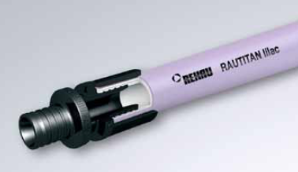
RAUTITAN lilac

- GENERAL
This section relates to REHAU RAUTITAN recycled water supply system, from the network utility supply authority recycled water main to designated points and appliances.

- System description
The REHAU RAUTITAN lilac plumbing system for recycled water applications of 16 to 63mm consists of:
- RAUTITAN lilac pipe
- PX fittings and sleeves
- threaded MX fittings

- Reference documentation
The documents referred to in this section are:
NCC / BCA Building Code of Australia
AS/NZS 3500 Plumbing and drainage set
AS/NZS 2492 Cross-linked polyethylene (PE-X) pipes for pressure applications
AS/NZS 2537 Mechanical jointing fittings for use with cross-linked polyethylene (PE-X) pipe for hot and cold water applications

Manufacturers documentation
Manufacturer’s and supplier’s documents relating to work in this section are:
REHAU RAUTITAN – Water, Gas & Heating Product book
REHAU Piping, Connection and System Guidelines – Technical information
RAUTITAN – Water Service – Technical Information

The above information is available from REHAU:
Web: www.rehau.com.au
Phone: 1300 768 033 (Australia only) or +61 2 8741 4500

- General system design and performance
Planning, installation and commissioning must comply with the following documents:
AS/NZS 3500.1 Plumbing and drainage – Part 1: Water Services
REHAU Piping, Connection and System Guidelines – Technical information
RAUTITAN – Water Service – Technical Information

Installers to be a member of the REHAU Authorised Installer Network RAIN, familiar with the materials and the techniques specified.

- Materials

Pipe materials
Pipe materials shall be PE-Xa/PE construction, consisting of PE-Xa inner layer and a PE outer marking layer, certified to AS/NZS 2492 for water service applications.
Suitable for use in recycled water applications in buildings in accordance with AS/NZS 3500.

Pipe performance specification

Product | RAUTITAN lilac
Colour | lilac
Marking (each meter of pipe length) | “Recycled or reclaimed water – do not drink”
Material | Flexible, high-pressure cross-linked polyethylene pipe PE-Xa (in accordance with DIN 16892/16893)
Pressure rating | PN20 (in accordance with AS/NZS 2492)
Design pressure | A Class.1-5/10bar (in accordance with ISO 15875)
Continuous operation | 70 °C at 1,000 kPa
Maximum operating temperature | 90 °C
short-term maximum temperature | 100 °C
Operational life time (at 70°C / 1,000 kPa) | 50 years
Available sizes in mm | 16 x 2.2mm 40 x 5.5mm  20 x 2.8mm 50 x 6.9mm  25 x 3.5mm 63 x 8.6mm  32 x 4.4mm
Australia and New Zealand approvals and certifications | AS/NZS 2492:2007  BRANZ appraisal no. 434  Watermark licence number LN01413

Connection – compression fittings and sleeves
Connections shall be axial compression sleeve mechanism, featuring the following benefits:
- Permanently sealing compression sleeve jointing technique
- Self-sealing pipe material – connection without the use of an O-ring
- Increased hydraulic properties based on expansion technology
- Approved for flush-mounted installation
- Robust jointing technique highly suitable for construction sites.
- Simple visual inspection
- Joint can be pressurised immediately after installation.
- Requires no calibration or deburring
- Same jointing technique and tools for water services, gas and heating installation

Fittings and sleeves shall be REHAU RAUTITAN PX or MX, Watermark approved and certified to AS/NZS 2537.

RAUTITAN PX Polymer fittings made of PPSU (colour: black) with tool tabs for precise attachment of the assembly tool RAUTOOL shall be used for threadless connections from 16-40mm.

RAUTITAN PX multi directional polymer sleeves made of PVDF (colour: black) with laser engraved production date shall be used for all connections from 16-40mm.

RAUTITAN MX DZR Brass fittings made of special dezincification-resistant brass, manufactured in accordance with AS2345, DIN EN 12164, DIN EN 12165 and DIN EN 12168 grade A (equivalent to highest requirement category), shall be used for all 16-63mm threaded connections and 50-63mm threadless connections.

RAUTITAN MX sleeves made of thermally annealed brass, manufactured in accordance with DIN EN 12164, DIN EN 12165 and DIN EN 12168, shall be used for connections 50-63mm.

- Manufacturer Warranty
Warranty period: 25 years
From: Date of completion of system testing.
For Terms and Conditions see REHAU RAUTITAN Warranty Certificate in the manufacturers standard form.

Technical specification – REHAU RAUTITAN Plumbing System

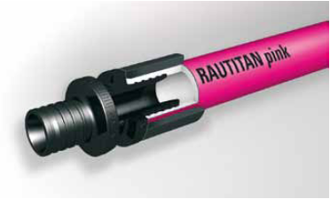
RAUTITAN pink

- GENERAL
This section relates to REHAU RAUTITAN Under Floor Heating / Cooling system.

- System description
The REHAU RAUTITAN system for under floor heating and cooling applications of 16 to 40mm consists of:
- RAUTITAN pink pipe
- PX fittings and sleeves
- threaded MX fittings

- Reference documentation
The documents referred to in this section are:
NCC / BCA Building Code of Australia
BS EN 1264 Floor heating - Systems and components
BS EN 13163 Thermal insulation products for buildings. Factory made products of expanded polystyrene. Specification
BS 7291 Thermoplastic pipes and associated fittings for hot and cold water for domestic purposes and heating installations in buildings

Manufacturers documentation
Manufacturer’s and supplier’s documents relating to work in this section are:
REHAU Piping, Connection and System Guidelines – Technical information
REHAU Under Floor Heating/Cooling – Technical Information

The above information is available from REHAU:
Web: www.rehau.com.au
Phone: 1300 768 033 (Australia only) or +61 2 8741 4500

- General system design, installation and commissioning
Planning, installation and commissioning must comply with the following documents:
BS EN 1264 Floor heating - Systems and components
REHAU Piping, Connection and System Guidelines – Technical information
REHAU Under Floor Heating/Cooling – Technical Information

Installers to be a member of the REHAU Authorised Installer Network RAIN, familiar with the materials and the techniques specified.

- MATERIALS

Pipe materials
Pipe materials shall be PE-Xa/PE construction, consisting of PE-Xa inner layer, an EVOH oxygen barrier, and a PE outer marking layer.
Suitable for use in heating and cooling applications in residential and commercial applications in accordance with BS EN 1264 and BS 7291.

Pipe performance specification

Product | RAUTITAN pink
Colour | Pink
Material | Flexible, high-pressure cross-linked polyethylene pipe PE-Xa (in accordance with DIN 16892/16893)
Pressure rating | PN20 (in accordance with AS/NZS 2492)
Design pressure | A Class.1-5/10bar (in accordance with ISO 15875)
Continuous operation | 70 °C at 1,000 kPa
Maximum operating temperature | 90 °C
short-term maximum temperature | 100 °C
Operational life time (at 70°C / 1,000 kPa) | 50 years
Available sizes in mm | 16 x 2.2mm 32 x 4.4mm  20 x 2.8mm 40 x 5.5mm  25 x 3.5mm
Australia and New Zealand approvals and certifications | AS/NZS 2492:2007  BRANZ appraisal no. 434

Connection – compression fittings and sleeves
Connections shall be axial compression sleeve mechanism, featuring the following benefits:
- Permanently sealing compression sleeve jointing technique
- Self-sealing pipe material – connection without the use of an O-ring
- Increased hydraulic properties based on expansion technology
- Approved for flush-mounted installation
- Robust jointing technique highly suitable for construction sites.
- Simple visual inspection
- Joint can be pressurised immediately after installation.
- Requires no calibration or deburring
- Same jointing technique and tools for water services, gas and heating installation

Fittings and sleeves shall be REHAU RAUTITAN PX or MX, Watermark approved and certified to AS/NZS 2537.

RAUTITAN PX Polymer fittings made of PPSU (colour: black) with tool tabs for precise attachment of the assembly tool RAUTOOL shall be used for threadless connections from 16 to 40mm. Protected by Australian Design Registration No. 327395, 327396 and 327397.

RAUTITAN PX multi directional polymer sleeves made of PVDF (colour: black) with laser engraved production date shall be used for all connections from 16 to 40mm.

RAUTITAN MX DZR Brass fittings made of special dezincification-resistant brass, manufactured in accordance with AS2345, DIN EN 12164, DIN EN 12165 and DIN EN 12168 grade A (equivalent to highest requirement category), shall be used for all threaded connections from 16 to 40mm.

- Manufacturer Warranty
Warranty period: 25 years
From: Date of completion of system testing.
For Terms and Conditions see REHAU RAUTITAN Warranty Certificate in the manufacturers standard form.

Technical specification – REHAU RAUTITAN Plumbing System

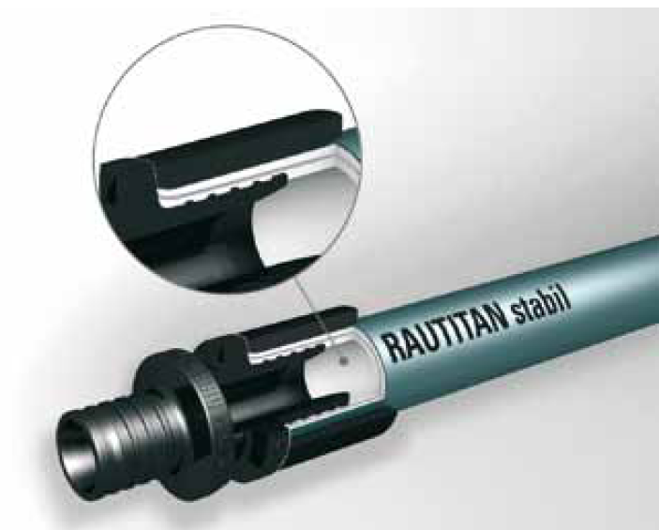
RAUTITAN stabil

- GENERAL
This section relates to REHAU RAUTITAN plumbing system for hot and cold water installation, from the network utility supply authority water main to designated points and appliances, and Under Floor Heating and Cooling.

- System description
The REHAU RAUTITAN stabil plumbing system for hot and cold water, and heating and cooling applications of 16 to 40mm consists of:
- RAUTITAN stabil pipe
- PX fittings and sleeves
- threaded MX fittings

- Reference documentation
The documents referred to in this section are:
NCC / BCA Building Code of Australia
AS/NZS 3500 Plumbing and drainage set
AS 4176 Multilayer pipe system for pressure applications
AS/NZS 2537 Mechanical jointing fittings for use with cross-linked polyethylene (PE-X) pipe for hot and cold water applications
AS/NZS 4020 Testing of products for use in contact with drinking water

Manufacturers documentation
Manufacturer’s and supplier’s documents relating to work in this section are:
REHAU RAUTITAN – Water, Gas & Heating Product book
REHAU Piping, Connection and System Guidelines – Technical information
RAUTITAN – Water Service – Technical Information

The above information is available from REHAU:
Web: www.rehau.com.au
Phone: 1300 768 033 (Australia only) or +61 2 8741 4500

- General system design and performance
Planning, installation and commissioning must comply with the following documents:
AS/NZS 3500.1 Plumbing and drainage – Part 1: Water Services
REHAU Piping, Connection and System Guidelines – Technical information
RAUTITAN – Water Service – Technical Information

Installers to be a member of the REHAU Authorised Installer Network RAIN, familiar with the materials and the techniques specified.

- MATERIALS

Pipe materials
Pipes shall be of composite construction, certified to AS 4176 respectively ATS5200.490 for pressure applications, consisting of PE-Xa inner layer, an aluminium oxygen barrier, and a PE outer marking layer.
Suitable for use in hot and cold water applications in buildings in accordance with AS/NZS 3500.

Pipe performance specification
Product | RAUTITAN stabil
Colour | Silver
Material | High-pressure cross-linked polyethylene pipe PE-Xa inliner (in accordance with DIN 16892), Aluminium
Pressure rating | PN20 (based on AS/NZS 2492)
Design pressure | A Class.1-5/10bar (in accordance with ISO 15875)
Continuous operation | 70 °C at 1,000 kPa
Maximum operating temperature | 95 °C
short-term maximum temperature | 100 °C
Operational life time (at 70°C / 1,000 kPa) | 50 years
Available sizes in mm | 16.2 x 2.6mm 32 x 4.7mm  20 x 2.9mm 40 x 6.0mm  25 x 3.7mm
Australia and New Zealand approvals and certifications | AS 4176 / ATS 5200.490  AS/NZS 4020  BRANZ appraisal no. 434  Watermark licence number LN21210

Connection – compression fittings and sleeves
Connections shall be axial compression sleeve mechanism, featuring the following benefits:
- Permanently sealing compression sleeve jointing technique
- Self-sealing pipe material – connection without the use of an O-ring
- Increased hydraulic properties based on expansion technology
- Approved for flush-mounted installation
- Robust jointing technique highly suitable for construction sites.
- Simple visual inspection
- Joint can be pressurised immediately after installation.
- Requires no calibration or deburring
- Same jointing technique and tools for water services, gas and heating installation

Fittings and sleeves shall be REHAU RAUTITAN PX or MX, Watermark approved and certified.

RAUTITAN PX Polymer fittings made of PPSU (colour: black) with tool tabs for precise attachment of the assembly tool RAUTOOL shall be used for threadless connections from 16-40mm.

RAUTITAN PX multi directional polymer sleeves made of PVDF (colour: black) with laser engraved production date shall be used for all connections from 16-40mm.

RAUTITAN MX DZR Brass fittings made of special dezincification-resistant brass, manufactured in accordance with AS2345, DIN EN 12164, DIN EN 12165 and DIN EN 12168 grade A (equivalent to highest requirement category), shall be used for all 16-40mm threaded connections.

- Manufacturer Warranty
Warranty period: 25 years
From: Date of completion of system testing.
For Terms and Conditions see REHAU RAUTITAN Warranty Certificate in the manufacturer’s standard form.

Technical specification – REHAU RAUTITAN Gas System

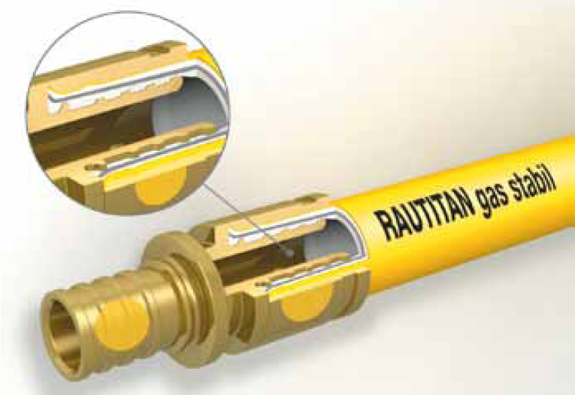
RAUTITAN gas stabil

- GENERAL
This section relates to REHAU RAUTITAN gas system for NG and LPG installation, downstream of the point of supply (as defined in AS/NZS 5601.1 - Section 1) to designated points and appliances.

- System description
The REHAU RAUTITAN gas stabil system for gas applications of 16 to 40mm consists of:
- RAUTITAN gas stabil pipe
- RAUTITAN gas fittings and sleeves

- Reference documentation
The documents referred to in this section are:
NCC / BCA Building Code of Australia
AS/NZS 5601.1 Gas installations
AS 4176.8 Multilayer pipes for pressure applications

Manufacturers documentation
Manufacturer’s and supplier’s documents relating to work in this section are:
REHAU RAUTITAN – Water, Gas & Heating Product book
REHAU Piping, Connection and System Guidelines – Technical information
RAUTITAN – Gas Installation System – Technical Information

The above information is available from REHAU:
Web: www.rehau.com.au
Phone: 1300 768 033 (Australia only) or +61 2 8741 4500

- General system design and performance
Planning, installation and commissioning must comply with the following documents:
AS/NZS 5601.1 Gas Installation – Part 1: General Installations
REHAU Piping, Connection and System Guidelines – Technical information
RAUTITAN gas Installation System – Technical Information

Installers to be a member of the REHAU Authorised Installer Network RAIN, familiar with the materials and the techniques specified.

- MATERIALS

Pipe materials
Pipes shall be of composite construction, certified to AS4176.8 for pressure applications, consisting of PE-Xa inner layer, an aluminium oxygen barrier, and a PE outer marking layer.

Pipe performance specification
Product | RAUTITAN gas stabil
Colour | Yellow
Material | High-pressure cross-linked polyethylene pipe PE-Xa (in accordance with DIN 16892), Aluminium
Continuous operating temperature | 60 °C
short-term maximum temperature | 90 °C
Continuous operating pressure | 70 kPa
Minimum designed service life | 50 years
Available sizes in mm | 16.2 x 2.6mm 25 x 3.7mm  20 x 2.9mm 32 x 4.7mm  40 x 6.0mm
Approvals and certifications | AS 4176.8-2010

Connection – compression fittings and sleeves
Connections shall be axial compression sleeve mechanism, featuring the following benefits:
- Permanently sealing compression sleeve jointing technique
- Self-sealing pipe material – connection without the use of an O-ring
- Increased hydraulic properties based on expansion technology
- Robust jointing technique highly suitable for construction sites.
- Simple visual inspection
- Joint can be pressurised immediately after installation.
- Requires no calibration or deburring
- Same jointing technique and tools for water services, gas and heating installation

Fittings and sleeves shall be REHAU RAUTITAN gas with yellow dot, approved and certified to AS 4176.8. Each fitting packed with the adjacent sleeves as one set into a bag.

RAUTITAN gas DZR Brass fittings with yellow dot, made of special dezincification-resistant brass, manufactured in accordance with AS 2345, DIN EN 12164, DIN EN 12165 and DIN EN 12168 grade A (equivalent to highest requirement category), shall be used for all 16-40mm connections.

RAUTITAN gas sleeves with yellow dot, made of thermally annealed brass, manufactured in accordance with DIN EN 12164, DIN EN 12165 and DIN EN 12168, shall be used for connections 16-40mm.

- Manufacturer Warranty
Warranty period: 25 years
From: Date of completion of system testing.
For Terms and Conditions see REHAU RAUTITAN Warranty Certificate in the manufacturer’s standard form.

